

What is a Tenancy Agreement?

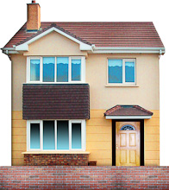

This guide goes with your tenancy agreement to help explain it. This includes information about what you pay to live in your home, looking after your home and other tenant rules.

|  |  |
| --- | --- |
| H:\CustomerFirst\Rebekah\Photosymbols\lores_images\Place_My_House-4.jpg  **What is supported living?**  **Supported living is not just for people who are 'able'. Anyone, regardless of their ability, can be supported to live in their own home with the right support.** | |
| * Supported living means that you are supported to live in the way that you want. * Your housing and support is built around you rather than you fitting in to a service. * You choose who you live with (if anyone). * You choose where you live. * In supported living, people are supported to take control of their life. |

**The Real Tenancy Test**

The real tenancy test is a quick test to be used in supported living housing to make sure tenants’ rights are being met.

It has been designed to support people with learning disabilities to understand whether a tenancy gives the person real tenancy rights or not.

There are 5 key (important) standards:

**The Real Tenancy Test**

**Tenancy rights in Supported Living**

Source: The real tenancy test NDTi Housing and inclusion Project

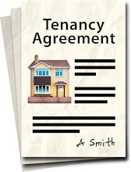**Your tenancy agreement**

**Is a written agreement about your housing. It includes what you pay to live in your home, looking after your home and other rules.**

**The agreement is between you and the landlord**

**Name of landlord: Parasol Homes**

**Your name here:**

**Address:**

**Date …………………………………………….**

**Contents –**

**What information is included in this booklet?**

**Page number**

Page 6

Page 7

Page 8

Page 9

Page 10

Page 11

Page 14

Page 15

Page 16

Page 17

Page 18

1. What is a tenancy agreement?
2. Types of tenancy
3. Who is the agreement between?
4. Who is the landlord?
5. What is rent?
6. What are our responsibilities?
7. What is tenant involvement?
8. When does a tenancy end?
9. What kind of furniture is provided?
10. Words explained

11. Tenancy agreement

|  |  |
| --- | --- |
|  |  |



1. **What is a Tenancy agreement?**

* 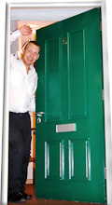It’s a document about living in a property.
* It explains the rules for living there.
* It gives your rights.
* It tells you what your responsibilities are.
* It gives details about your rent.
* It will show when your tenancy begins.



1. **Types of Tenancy**

**An Assured tenancy**

An assured tenancy gives you the right to live in your house for a long time as you follow the rules.

The law gives the person rights to:

* control their home so that they can stop other people from freely entering
* challenge rent increases
* get certain types of repairs done
* pass their tenancy to someone else in certain circumstances
* live in their accommodation until their landlord gets a court order to evict them.

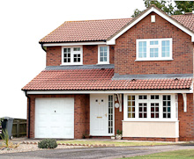**An Assured Shorthold tenancy**

Sometimes a tenancy may be for a set time. This is called an Assured Shorthold Tenancy.

The law gives the person rights to:

* get information about their tenancy
* control their home so that they can stop other people from freely entering
* get certain types of repairs done
* live in their accommodation until their landlord gets a court order to evict them.

1. **Who is the agreement between?**



* The agreement is between your landlord, usually the owner of the property.



* If the home is owned by another housing association, this will be shown in your agreement.

1. **Who is the Landlord?**

The person or organisation responsible for:

* Collecting rent.
* Carrying out repairs

Because they own or manage the

property you live in.

1. **What is rent?**

Rent is the amount of money to pay for the use of the property you will be living in. This is paid on a regular basis to your landlord.

**This may include things like:**

* Electricity bills
* Heating bills
* Gardening
* 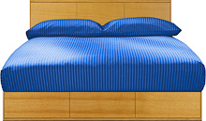 Water Rates
* Telephone
* Furniture Replacement
* Household Insurance (Insurance is money you pay in case something goes wrong with your personal possessions in your home).

**These things are not included in your agreement so you will need to make your own arrangements.**

1. **What are your responsibilities?**

To arrange for your rent to be paid on time.

**How do I pay?**

The three main ways you can pay your rent are:

* By standing order
* By cheque



* By cash
* Via Housing Benefit Direct to your landlord

Sometimes charges can increase (go up), decrease (go down) or stay the same.

**What else is your responsibility as a a tenant?**

* Tell your care provider if you will be away for more than 7 days.
* You or your visitors must not cause a nuisance to anyone else in the house and their visitors or staff.



* Not to harass or be violent towards anyone for any other reason.



* Not to play music or the TV so loudly that it disturbs someone else.

**What else maybe your responsibility?**



* To get written permission from the landlord and inform your care provider before keeping a pet.

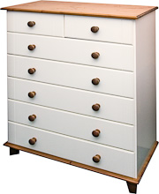

* Not to damage the fittings in the house, or anyone else’s property.

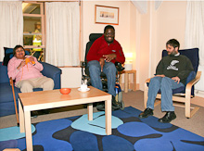

* If you live in a shared house, you must stick to the house rules.

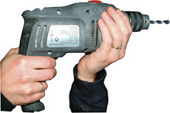

* To tell the support worker if anything is broken or needs repairing.

1. **What is tenant involvement?**

Your landlord should involve you in how they manage your property.

Your care provider will organise things like:



* House meetings



* Have your say at meetings.



* Presentations and letters to keep you up-to-date.

1. **When does a tenancy end?**

**A tenancy may end if:**

* You break the agreement or tenancy conditions.
* You have not paid your rent.\*

**\***You will be advised about breaches or arrears and given help to keep your tenancy.

**You may decide to move out if so:**

* You need to let your landlord know within 1 month before moving out.\*
* 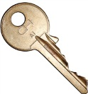You must return the key.
* Take all your things
* Leave everything clean and tidy.

\*Before you move your landlord may visit to arrange the end of your tenancy.

1. **What kind of furniture is provided?**

Your landlord may provide you with things like:

C:\Users\Debbie\AppData\Local\Microsoft\Windows\Temporary Internet Files\Content.IE5\CZR2AH1W\MC900089650[1].wmf

Washing Machine

C:\Users\Debbie\AppData\Local\Microsoft\Windows\Temporary Internet Files\Content.IE5\YT9VZOHZ\MC900286950[1].wmf

Cooker

C:\Users\Debbie\AppData\Local\Microsoft\Windows\Temporary Internet Files\Content.IE5\YT9VZOHZ\MC900036412[1].wmf

Fridge

Talk to your landlord before you move into your new home about how the above items will be paid for

**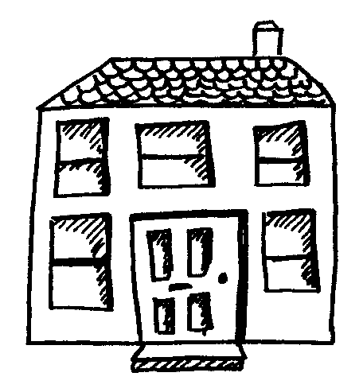Words explained**

**Tenancy agreement** – gives you the right to live in a house or a flat.

**Rent** – what you pay to live in the house or flat.

**Landlord** – is the organisation or person who owns your house or flat.

**Tenant** – is your name, saying you are renting your house or flat.

**Inventory** - a list of all the furniture and equipment which belongs to the landlord, but which you can use.

**Insurance** – money which is paid in advance to put things right if anything goes wrong in the house.

**Statutory approval or consents** – written legal permission for any building work if the local council needs this for changes to your property

****

**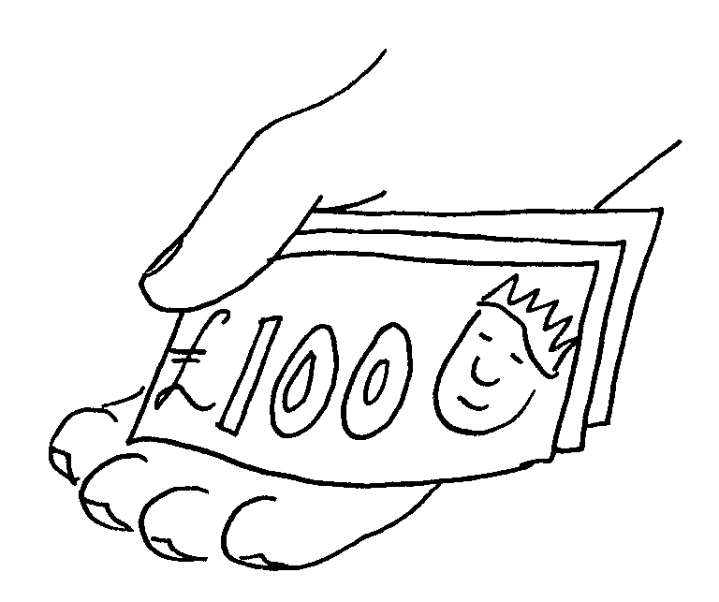**



You are the Tenant

**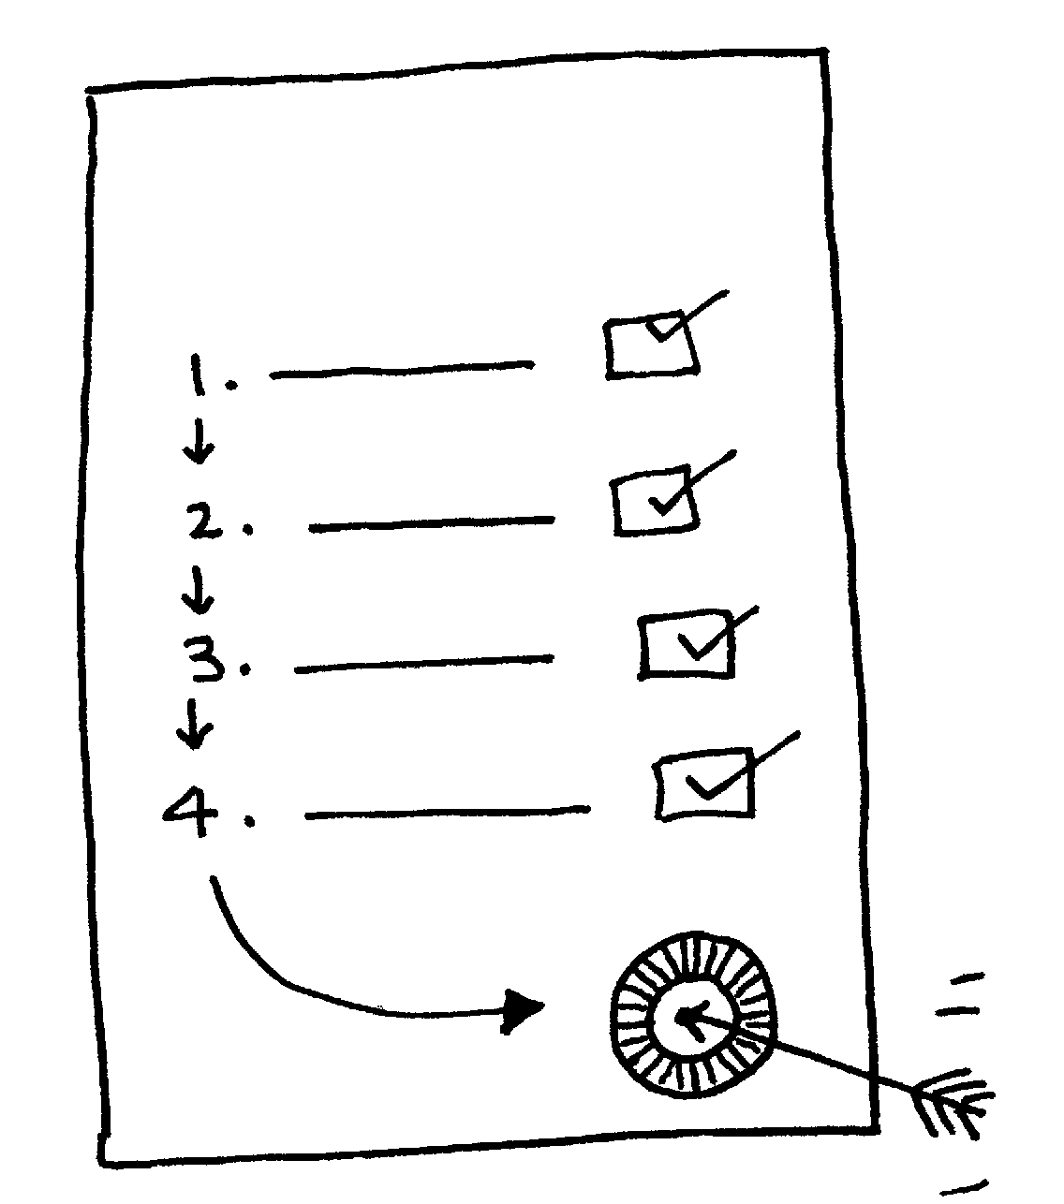**

What You Can Use

Repairs and Replacements

**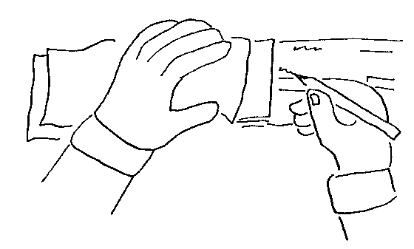**

**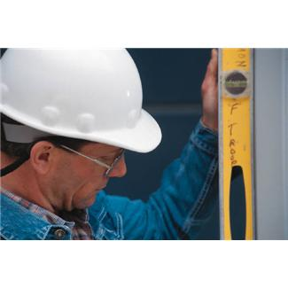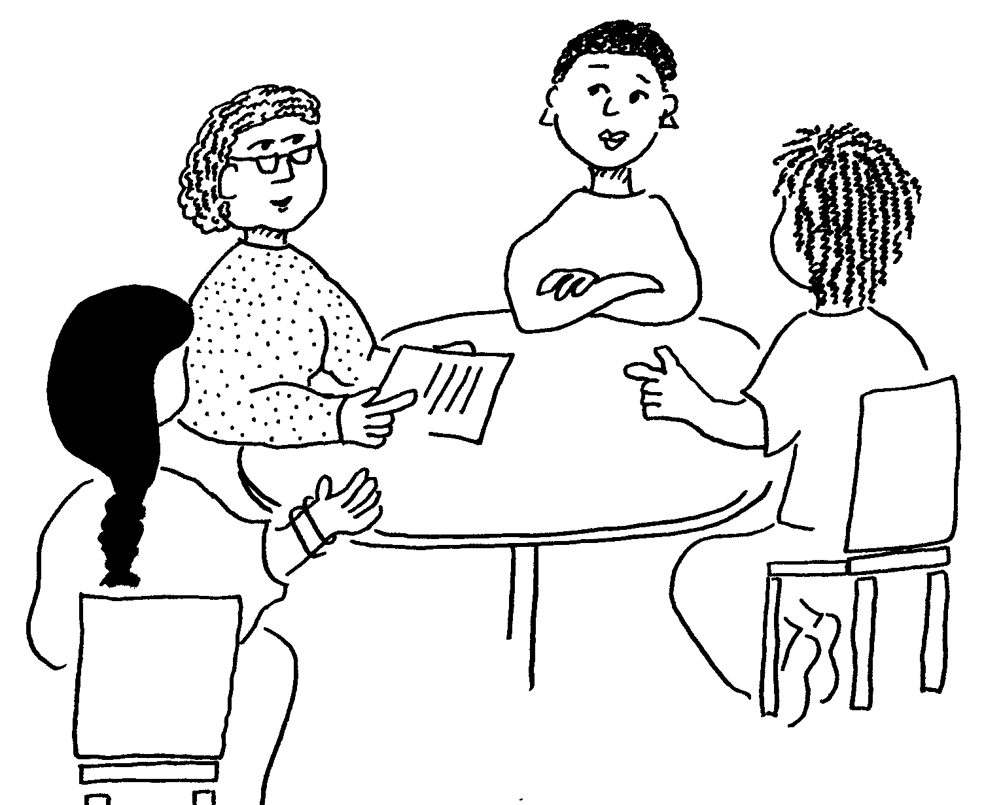**

1. **Tenancy Agreement Contract**

**The agreement is between the Landlord**

**

HOMECARE

**And you the tenant**

**Your address**

**Description of your home (flat, house, etc)**

C:\Program Files (x86)\Microsoft Office\MEDIA\CAGCAT10\j0185604.wmf

**Date your tenancy starts**

…………………………………………………….

**Type of tenancy**

…………….Assured Shorthold Tenancy………………



Your rent is £…. every month

Total £……. every month

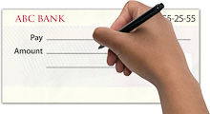

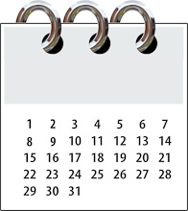

You must pay rent every month.

Rent will be taken out of your bank account each month if you sign a form to say this is ok.

We will talk and write to you if we need to change

your rent.

**What services are included in the rent?**

Your rent will pay for:

|  |  |  |
| --- | --- | --- |
| Heat.jpg Light.jpg | Lighting and heating and hot water | □ |
| Tap.jpg | Water and sewage | □ |
| Telephone2.jpg | Telephone | □ |
| Fire_Alarm.jpg Fire_Extinguisher.jpg | Alarm system and fire safety equipment | □ |
| Bed.jpg | Furnishings (you will be given a list of furniture provided | □ |
| Dusting.jpg | Cleaning of areas you share | □ |
| Gardening.jpg | Gardening of the areas you share | □ |
| Minicom(Textphone).jpg | Personalised Technology | □ |
| Policy.jpg | Insurance for the building, equipment and furniture. You must insure your own possessions | □ |
| Cleaner(Spray).jpgWindow.jpg | Window cleaning | □ |
| Shower_Accessible.jpg Access_Ramp.jpg | Other things (to be completed at the time of the let) | □ |

If a box is not ticked, you must pay for it yourself.

**What the landlord must do**

|  |  |
| --- | --- |
| Tariq-3.jpg | Mend things which break, like heating, plumbing and electrics |
| Drill.jpg | Tell you how they fix things that are broken |
| Complaints_Policy.jpg | Tell you how to make a complaint. If He fails to respond to your complaint or you are not satisfied with the outcome you can take your complaint to the Ombudsman. |
| Code_of_Conduct.jpg | Tell you about other rules they and you must follow |

**What you must do as the tenant**

|  |  |
| --- | --- |
| Mop_Floor.jpg Sweep-2.jpg | Keep your home clean and tidy |
| Talk_to_Manager.jpg Letter_in_Envelope.jpg | Tell your landlord if you need something fixing |
| Home_Inspection-3 | Let the landlord in to your home to fix it |
| Cat.jpg Goldfish.jpg | Ask if you want to keep any pets |
| Home_Inspection-11 | Keep any house rules that go with this agreement especially about health, fire and safety |
| Holiday_shopping | Tell your landlord if you will be away for more than 7 days |
| Home_Inspection-19 | Keep your home nicely decorated |
| Fill_form_ownColours.jpg | If you want to decorate your room you will need to talk to the landlord |
| Place_Building_Work | Get permission in writing from the landlord if you want to make changes to your home. |
| Months | You must also tell the landlord when you want the work to be done |
| Letter_in_Envelope | The Landlord will write to you to let you know if it is ok to do the work |
| Bank_form1Cheque_write | You must get any necessary statutory approvals or consents and pay for these |
| 20101014114134529_0001 | You can find someone local to do the work, or ask the landlord to do it |
| Cheque_write | If you find someone yourself, the landlord needs to check them first. You will need to pay them yourself |
| Plan | Show the landlord plans and details of the work you want |
| Home_Inspection-10 | The landlord will come and check the work when it is finished |
| Own_money.jpg | If you ask the landlord to do the work they will arrange everything, then you will pay the landlord at the end |
| Paint_Roller | Sometimes the landlord will need to change things back again or decorate if you move out |
| Money | You would have to pay for this too |

**What you must not do**

|  |  |  |
| --- | --- | --- |
| Cross.jpg | **X** | You must not damage your home, or fittings |
| Threaten.jpg | **X** | You must not upset your neighbours |
| Shouting.jpg | **X** | You must not be too noisy |

**What the landlord must do**

|  |  |
| --- | --- |
| Tariq-3.jpg | Mend things which break, like heating, plumbing and electrics |
| Drill.jpg | Tell you how they fix things that are broken |
| Complaints_Policy.jpg | Tell you how to make a complaint. |
| Code_of_Conduct.jpg | Tell you about other rules they and you must follow |

**Moving out**



You must tell your landlord 1 month before you move out of your house/flat.

When you move out you must

Key_hand4.jpg • Give the keys to us

Move_House.jpg • Take all your things

Dusting.jpg • leave everything clean and tidy

**Breaking the Rules**

If you break the rules the landlord might ask you to leave. There will be a meeting about this before anything is done.

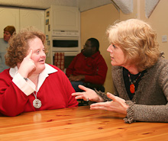

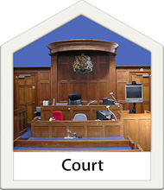

If you break the rules you can only be made to leave after your landlord has gone to a Court of Law.

The Court will make you leave if they agree you have broken the rules.

**Our Standards**

We will tell you about the aims and standards for our services.

We have agreed standards for our services for:

* Your tenancy.
* Repairing and maintain your home.
* Cleaning and gardening services.
* Collecting rent and missed payments.
* How we deal with complaints.
* Dealing with anti-social behaviour.

**The basic standards**

* We respect the rights of people with learning disabilities
* We will promote your independence.
* We will do our best to give you the choice of where and how you live.
* We will listen to your ideas about making our services better.

|  |  |
| --- | --- |
| **j0398403[1]**j0297161[1] | Copies of this Tenancy Agreement |
|  |  |
| j0431601[1]j0297161[1] | Signed copies of this contract will be held by the service user |
|  |  |
| j0155006[1] | or their representative |
|  |  |
|  | and with the Landlord |
|  |  |
| j0431601[1]j0297161[1] | Signed  ………………………………………………………………….. |
|  |  |
| bd06695_[1]  Family group | Witness (family/friend/advocate)  ………………………………………………………………….. |
| new_directions_logo |  |
|  | The Landlord  ………………………………………………………………….. |
|  |  |
| j0404133[1] | Date ………………………………………………………………….. |